**Bangladesh University of Business and Technology**



**Project Title**

**Student Information**

Course Name: Software Development II

Course No: CSE 200

Course Teacher: Md. Mahbubur Rahman (Assistant Professor)

**Submitted by**

Mohammad Ashraful Islam

ID: 15162103013

SK. Tanvir Rahman Razowana Khan Shatu

ID: 15162103041 ID: 15162103037

**B.Sc. Engg in CSE**

Intake: 32nd (Sec: 01)

Student Information

Introduction:

The project “**Student Information a C# .Net Project**” is designed to deal with all kinds of student details ranging from academic reports, university information, course curriculum, batch details and all other resources as required. All student details can be tracked with the aid of this system and can be made useful for reporting purposes.

Here is a basic procedure

1. User runs the software.
2. Software waits for username and password.
3. User enters username and password.
4. Software open database connection and query with the user input.
5. If Software found the User, it allows User to enter next win form.
6. Software passes username to the next win form.
7. User get a message with username in next win form.

Objective:

The main objective of the C# project on Student Information is to manage the details of student, logins, and courses. It manages all the information about student profiles. The project is totally built at administrative end and thus only the administrator is guaranteed the access. The purpose of the project is to build an application program to reduce the manual work for managing the student, logins, and profiles.

Hardware & Software Requirements:

Hardware Requirements:

Processor : Intel® Core™ i5 CPU M460 @ 2.53GHz 2.53GHz

RAM : 4 GB or More

Hard disk : 80GB or More

Software Requirements**:**

Front End : C#.net(2015)

Back End : Sql Server

Operation System : Windows 7 or Windows 8 or Windows 10

Functionalities:

* Provides the searching facilities based on various factors. Such as student, courses, address, semester, phone number.
* It tracks all the information of logins, profiles etc.
* Manage the information of logins
* Shows the information and description of the students.

Screenshots:

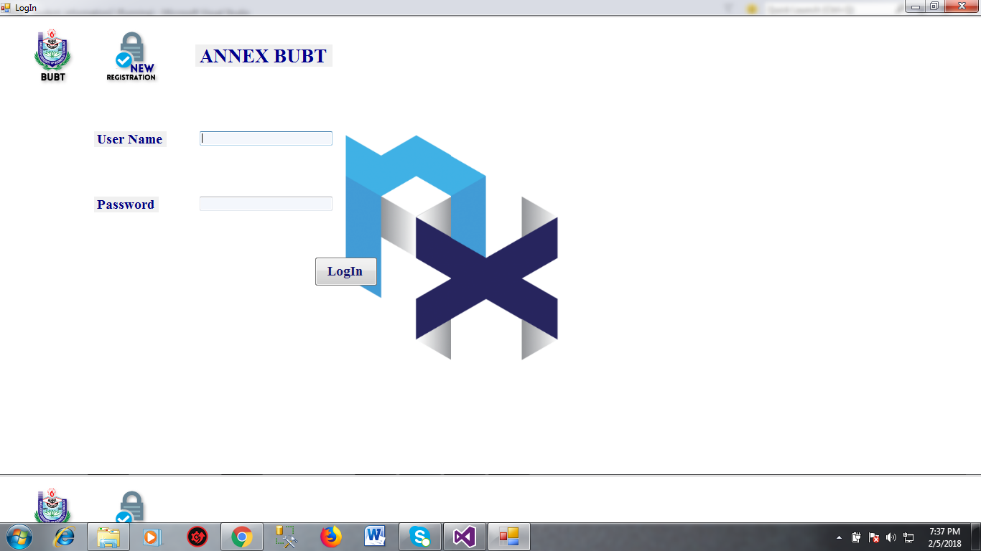

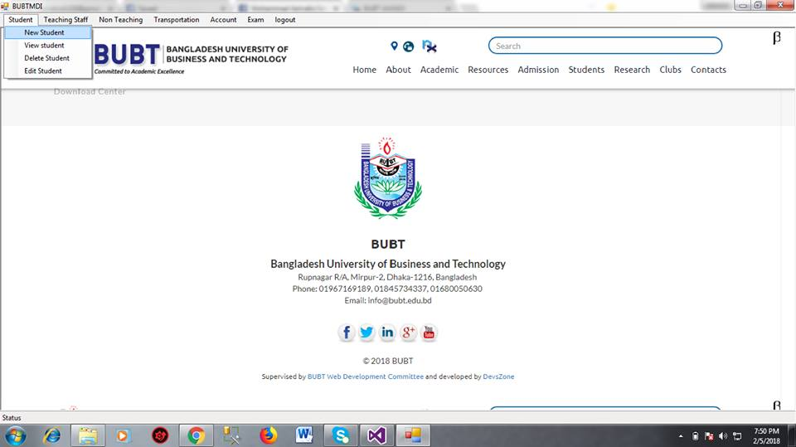

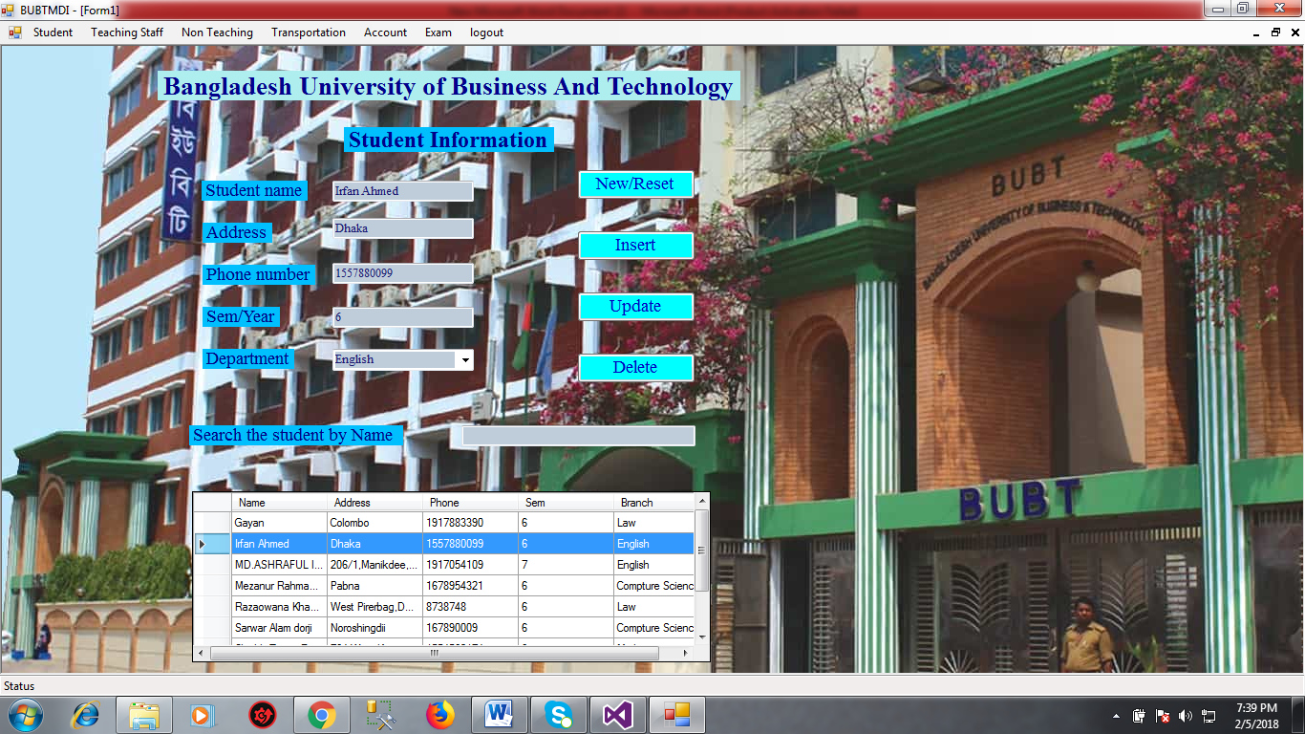

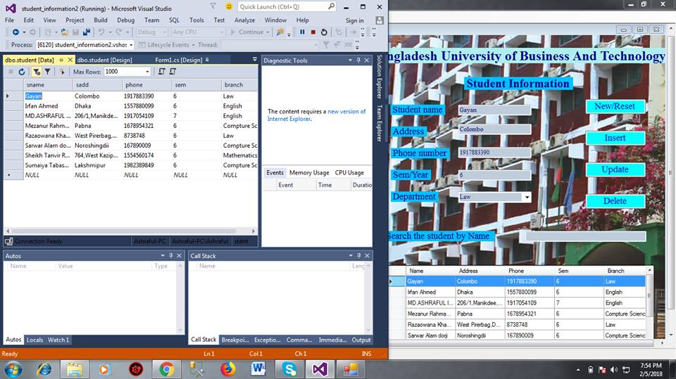

Conclusion:

The project has been carefully designed and efforts have been made to make the system totally error-free. It is efficient and less time consuming in nature.It is also important to note that the system is robust in nature. Also no malfunction can be caused from outsiders. The software used in the system provides ample scope for future modifications.